Commissionerate of Collegiate Education
Government of Andhra Pradesh
GDC MADAKASIRA DECEMBER TO MARCH- 2024 -25
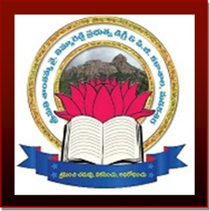
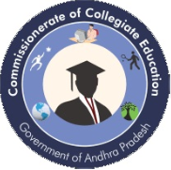
S.Y.T.R GOVERNMENT DEGREE COLLEGE
(Accredited by NAAC with ‘B’ grade)
Near Begarlapalli Cross, Amarapuram Road,
Madakasira,
Anantapur District, Andhra Pradesh-515301.
Mail: jkc.gdcmadakasira@gmail.com

Vision: To impart higher education with quality and Provide passport to the Students for Global citizenship.
Editorial Board | Month: DECEMBER TO MARCH Year: 2024 -2025 Vol: Issue:
 | Contents | Page No:
 | 1.Staff Achievements | 00
 | 2. Student’s Achievements | 0
From Principal’s Desk | 3. Community Corner | 01
 | 4. Departmental Activities | 02-12
 | 5. Any other important Information | 13-29

DEPARTMENTAL ACTIVITIE
DEPARTMENT OF POLITICAL SCIENCE & PUB ADMN
DEPARTMENTAL ACTIVITIES

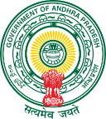
S.Y.T.R GOVERNMENT DEGREE COLLEGE, MADAKASIRA.

DEPARTMENT OF POLITICAL SCIENCE, PUB ADMN&HISTORY
DEPARTMENTAL ACTIVITIES
Name of the Activity/ Event: FIELD TRIP (SACHIVALAYAM)
Date: 17/12/2024
Name of the Department Lecturers: 1.Dr V. Murali Krishna 2.H.S.Kristappa 3.N.SaiGokul Kishan
No. of the Students Participated: 25
Objectives of the Activity/ Event:
The objectives of a field trip to a Sachivalayam (a government office that provides public services in India) can be diverse, depending on the focus of the trip.
1. Understanding Government Functions:
2. Civic Awareness:
3. Experiencing Public Service Delivery:
4. Encouraging Civic Responsibility:
5. Exploring Administrative Careers:
6. Learning about Government Schemes:
7. Interactive Learning:
8.Practical Application of Knowledge:

Description about the Activity/ Event:
The field trip to a Sachivalayam is an educational excursion aimed at providing students with firsthand experience of how local government offices operate. During this trip, students will observe the various administrative functions carried out in a Sachivalayam, such as issuing certificates, providing community services, and assisting citizens with their government-related tasks. The students will also get a chance to interact with government employees, ask questions, and see how the local administration manages the delivery of public services to the community.

Outcome of the activity/event:

1.Enhanced Civic Understanding
2.Increased Awareness of Public Services
3.Improved Sense of Civic Responsibility
4.Career Inspiration
Practical Application of Knowledge
Critical Thinking and Problem-Solving
Development of Communication Skills

In summary, this field trip will serve as a valuable educational experience that allows students to directly engage with their local governance system, gaining knowledge that will serve them in their personal, academic, and professional lives.

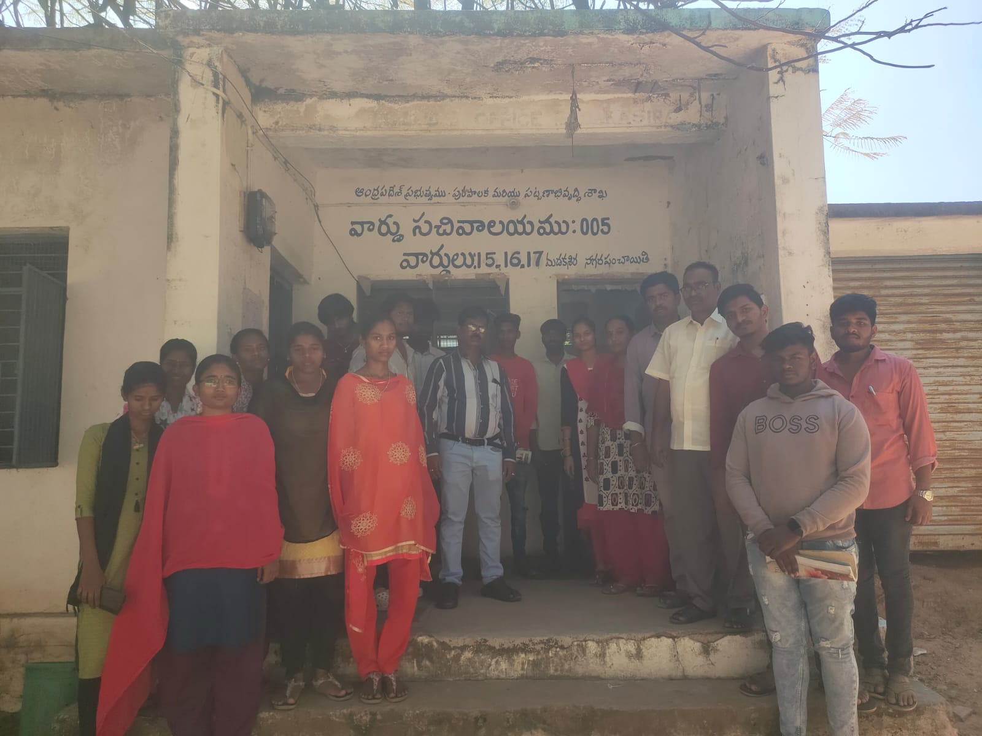
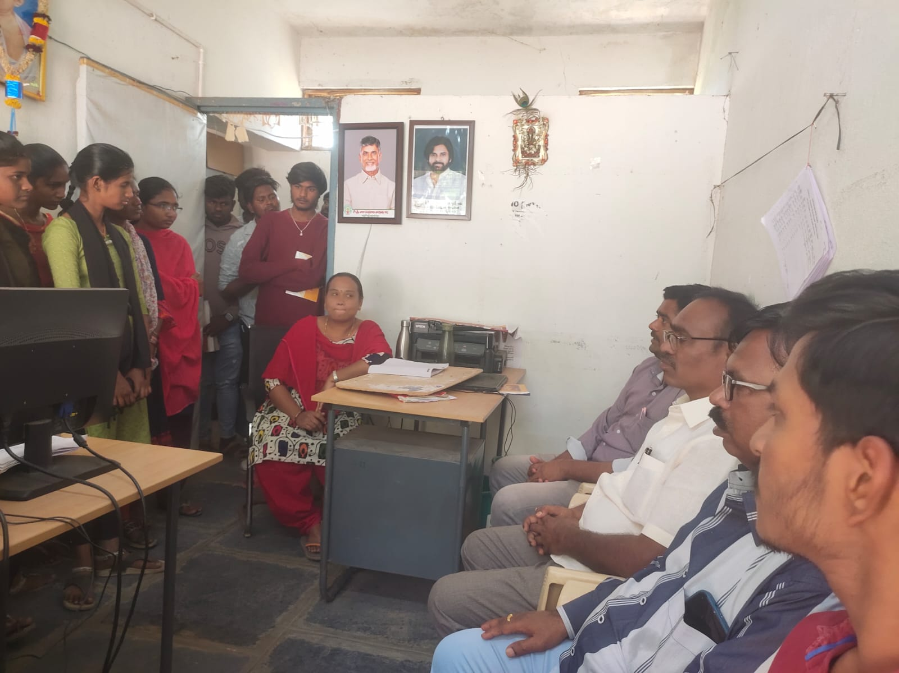

ATTENDANCE SHEET OF THE PARTICIPANTS

DEPARTMENT OF ENGLISH
A one month long On-the -Job Training program on Fundamentals of Computers organized to Junior College Students of Govt. Vocational Junior College, Madakasira and Govt. Junior College, Gudibanda on 06.12.2024. Dr. G. Sreenivasulu, Principal of SYTR GDC, Madakasira, Sri. Mahesh, Principal of GVJC, Madakasira and other faculty members of GDC and GJCs of Madakasira and Gudibanda and 240 students of Junior Colleges participated in program.
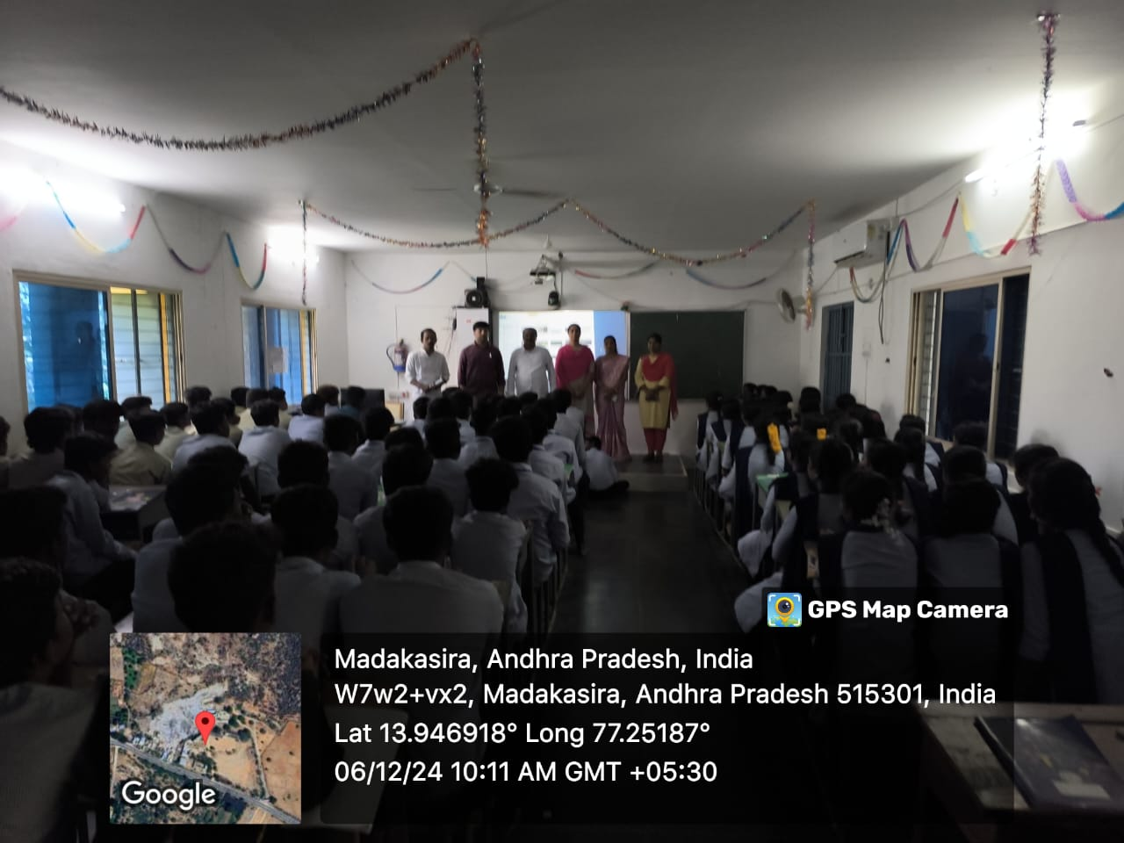
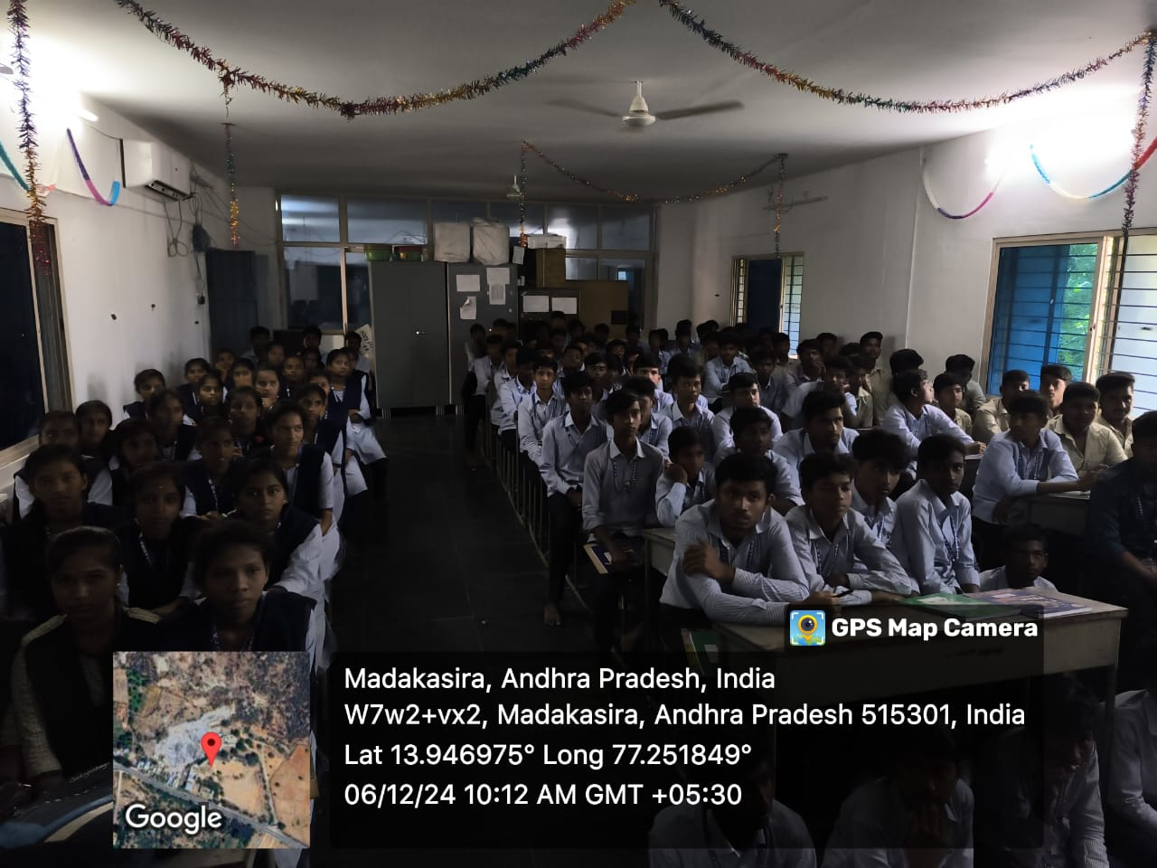

EVENT: Department of English participated in National AIDS Day rally organized by NSS Unit on 01.12.2024.
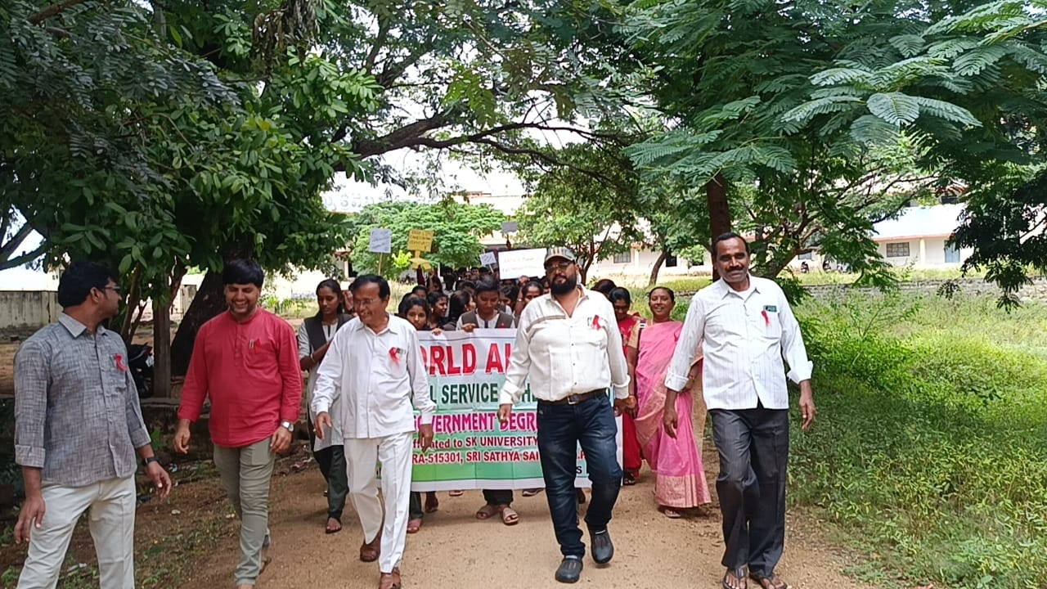
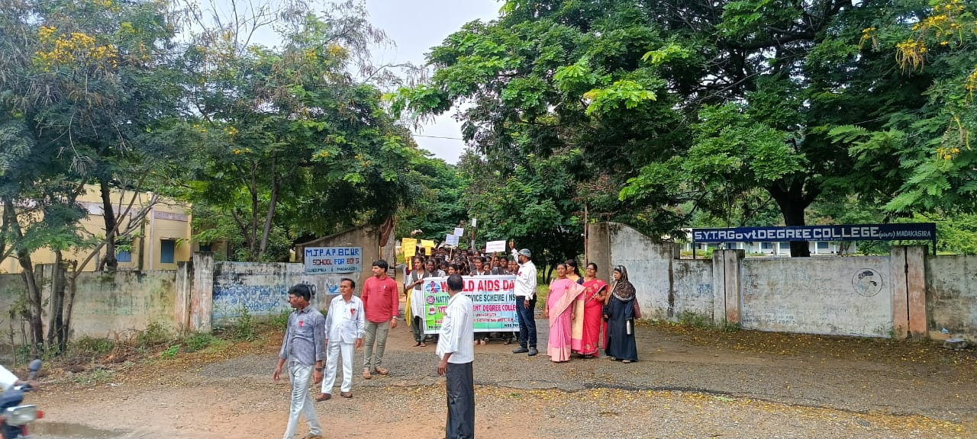
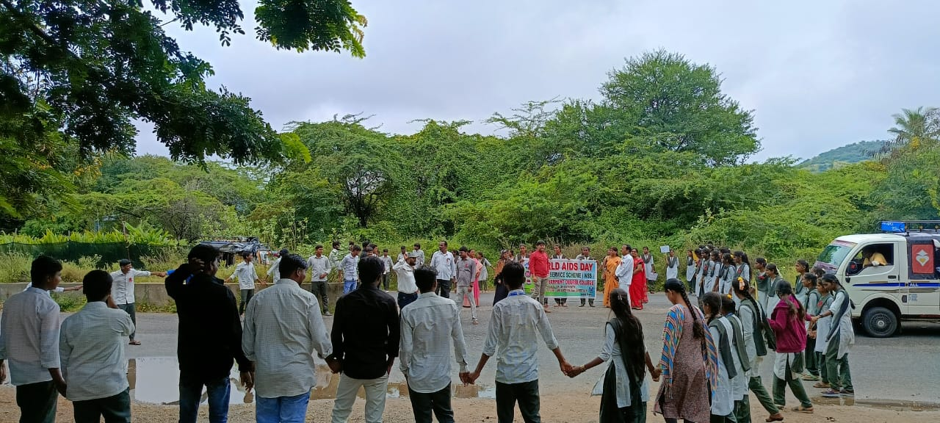

EVENT:- Dr. Chandrasekhar Naik, HOD, Department of English participated in National Consumers Day Celebrations along with Vice-Principal Dr. E. Nagaraju organized by Department of Commerce on 24.12.2024
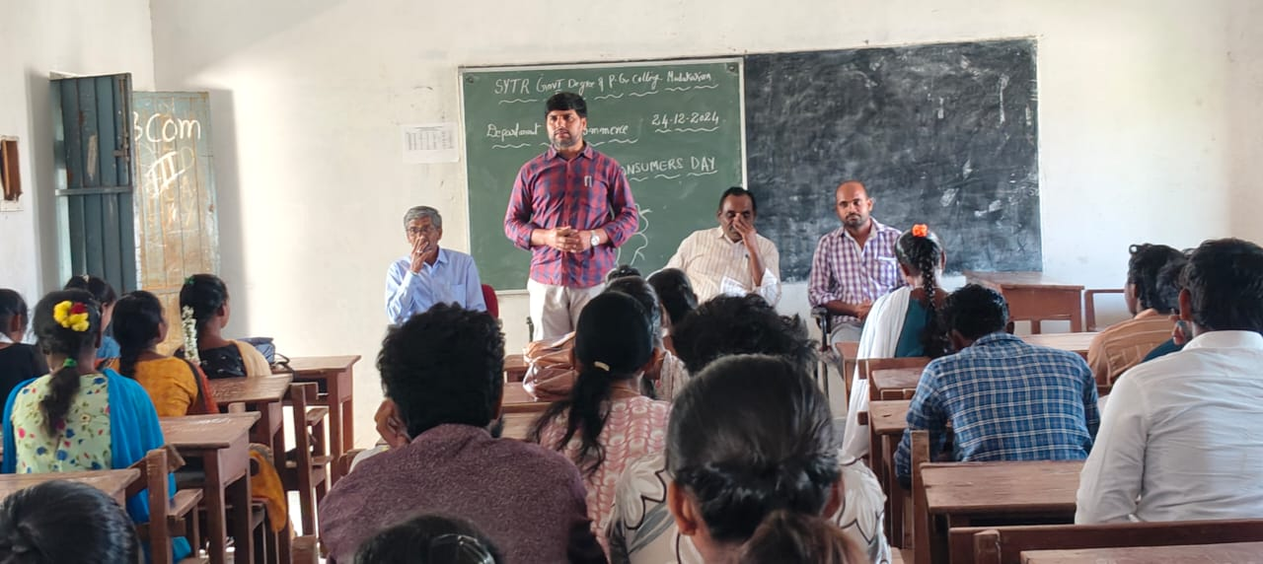
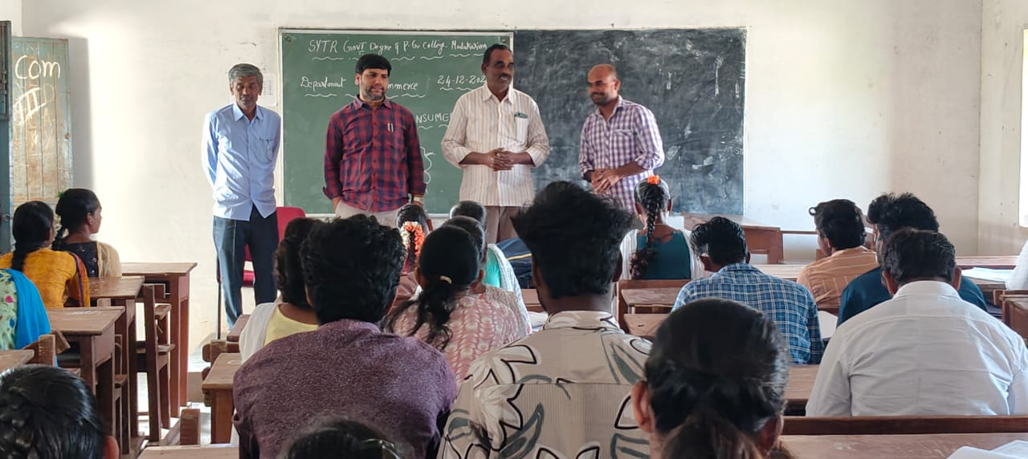

EVENT: The participation of Junior College Students in OJT practical sessions during the training program in the mid December 2024.
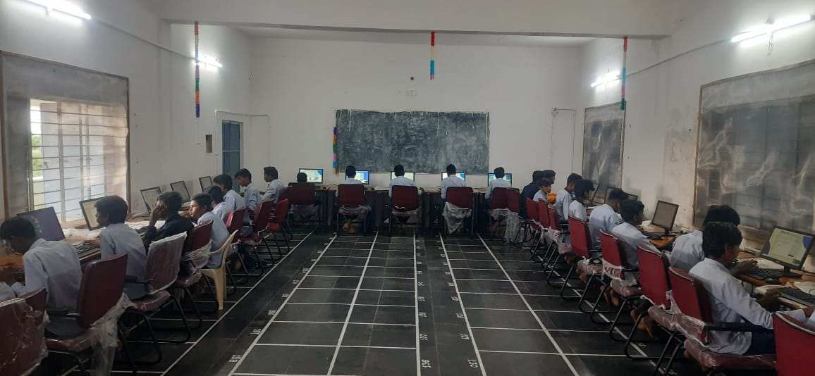
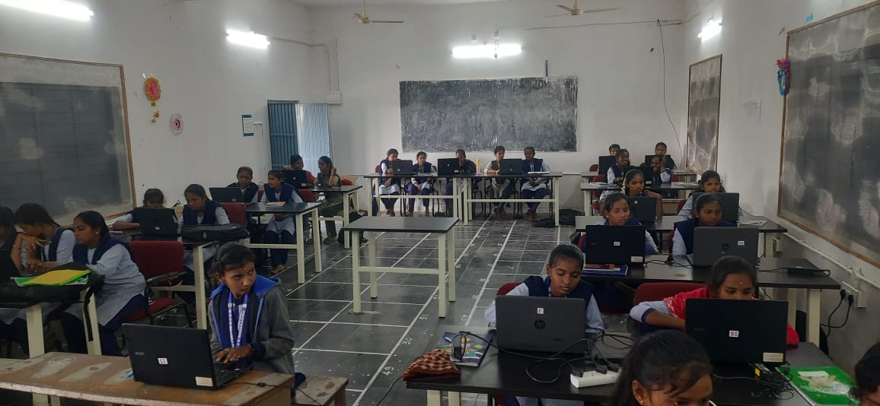

EVENT: Department of English encouraged the final year students of BA/B.Com/B.Sc to enroll in Online Certification course on "Effective Speaking and Listening Skills" offered by Wadhwani Foundation. 32 students enrolled and 26 students completed the course and received certificates on 30.12.2024.
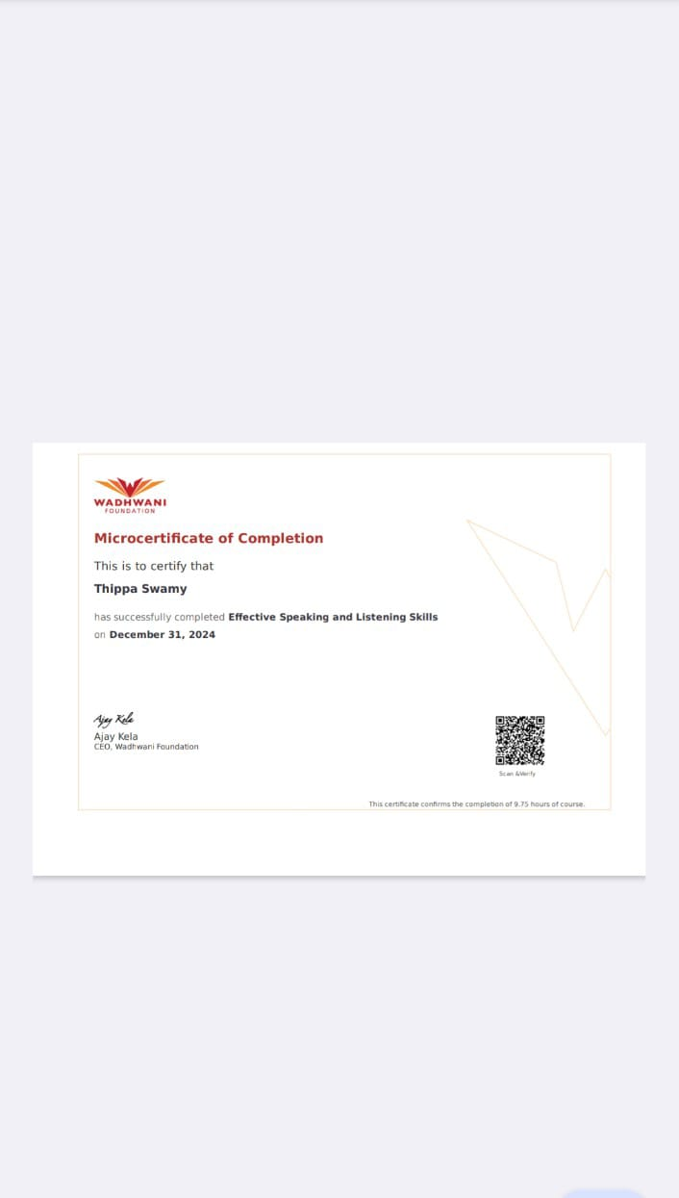
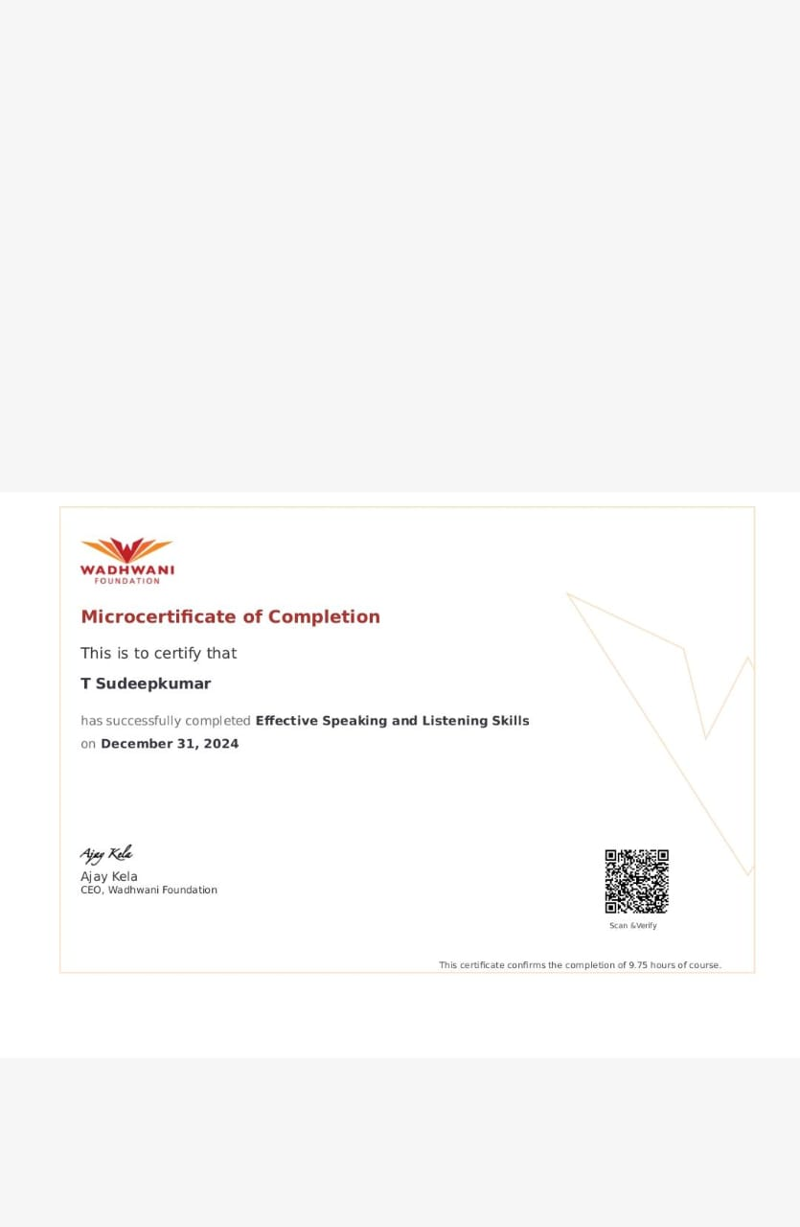
EVENT: The IQAC has conducted the Valedictory Function of the On The Job Training program to Junior College Students of Madakasira and Gudibanda and distributed certificates to the Trainees. Dr. G. Sreenivasulu, Principal of SYTR GDC, Dr. E. Nagaraju, Vice- Principal, Smt. R. Hemalatha, Lecturer in Zoology, Sri. Mahesh, Principal GVJC, Madakasira, Dr. Chandrasekhar Naik, IQAC and The program Coordinator and teaching staff from Govt. Junior Colleges of Madakasira and Gudibanda and Govt. Degree College along 256 students participated in the event on 08.01.2025.
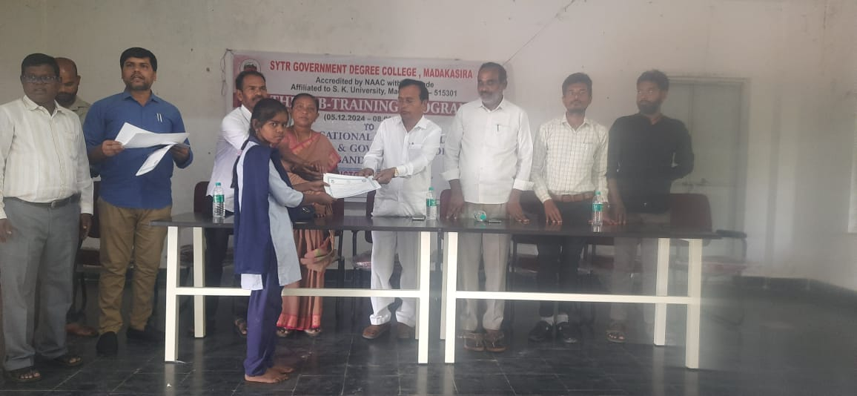
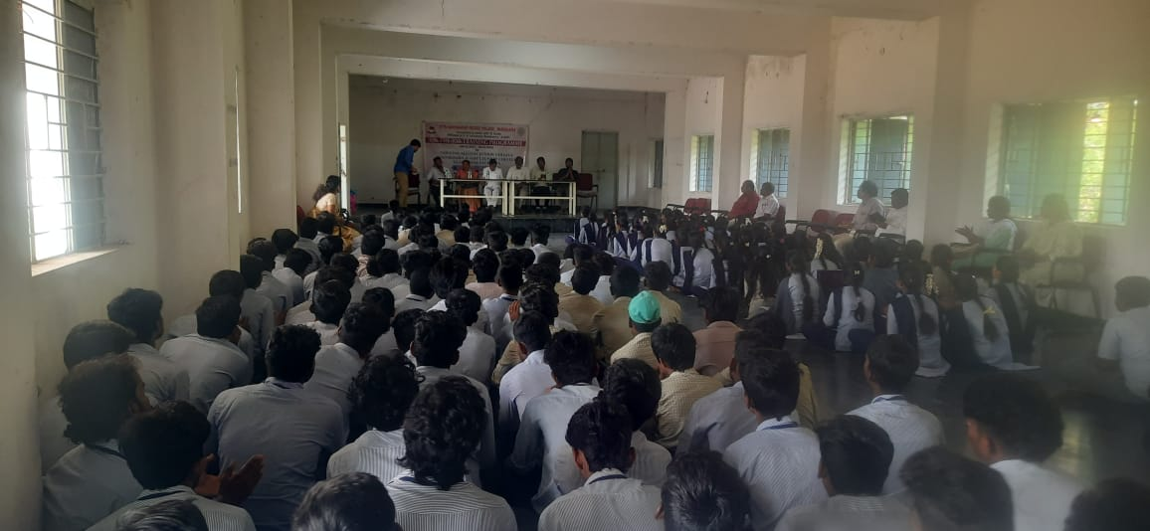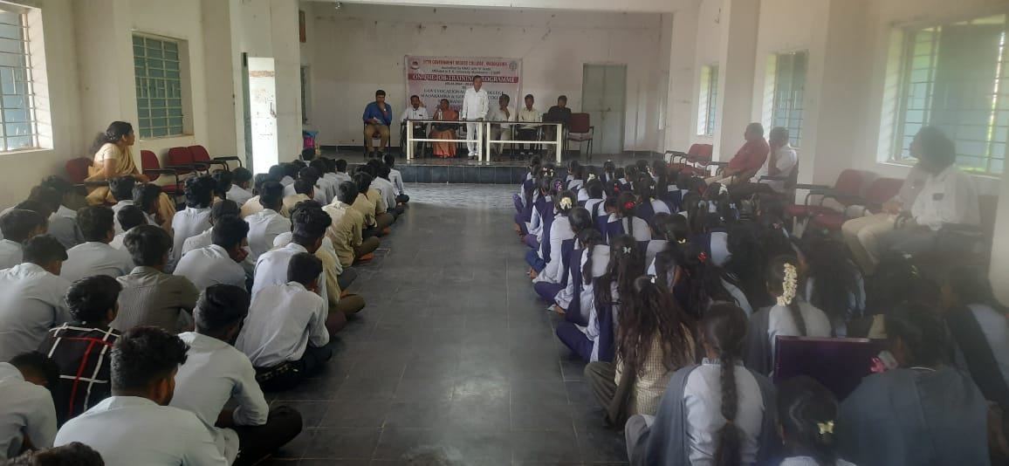
EVENT: The Department of English has participated in "Rangoli Competition" conducted by Women Empowerment Cell and NSS Units on the eve of Sankranti Festival which reflects the culture of Andhra Pradesh on 09.01.2025.
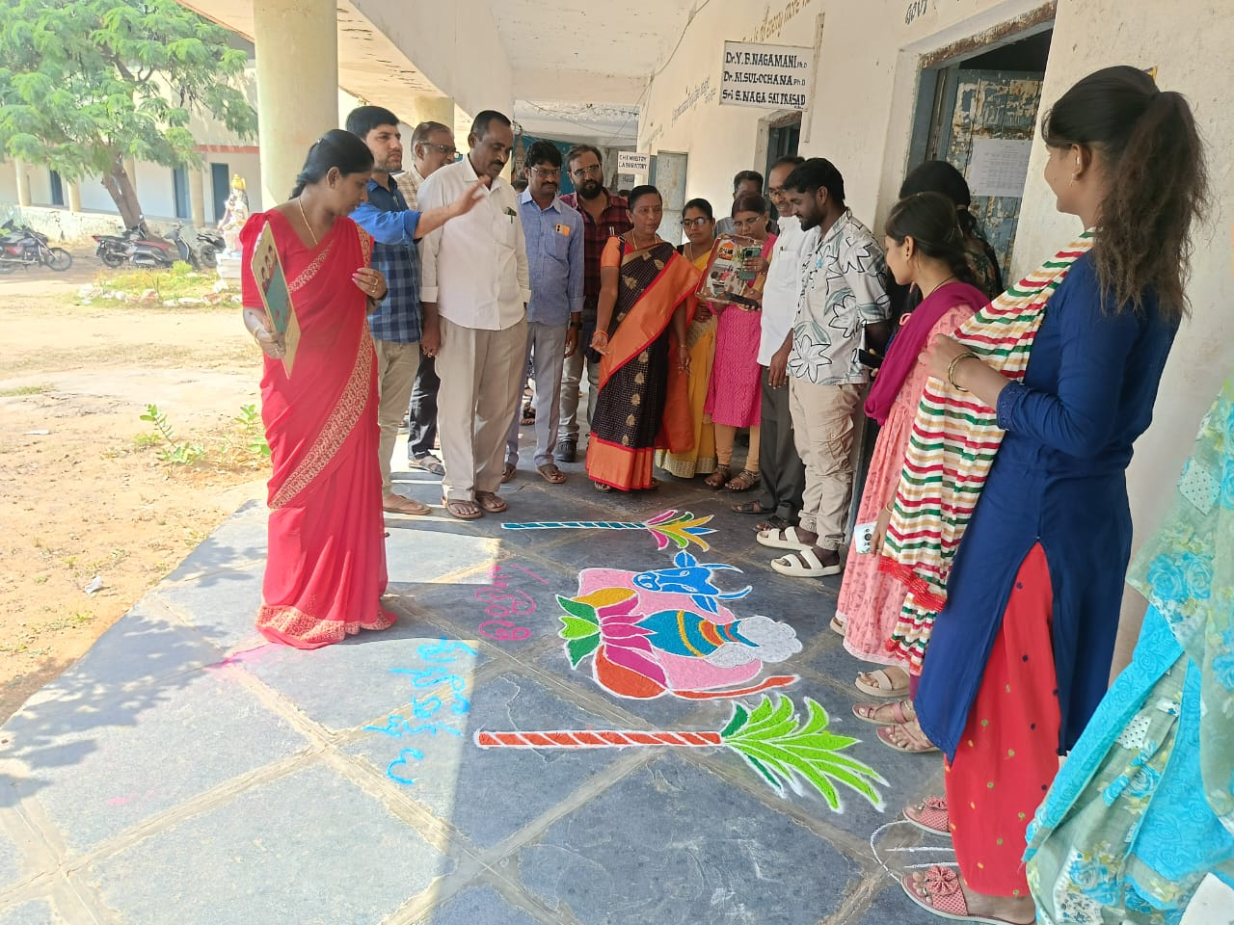
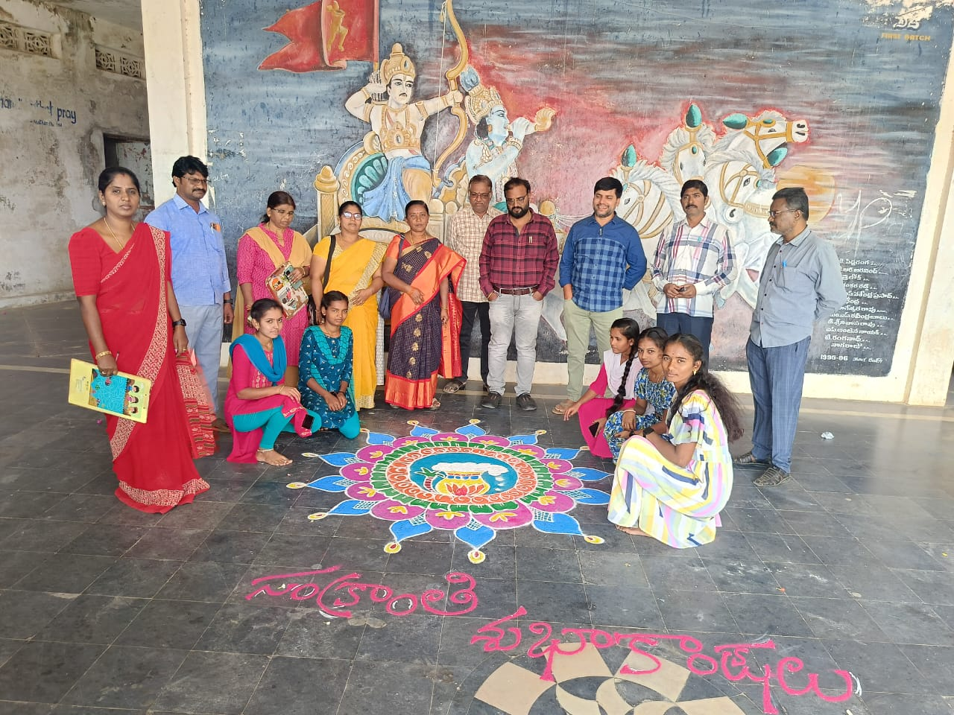

EVENT: NATIONAL YOUTH DAY ON 12.01.2025
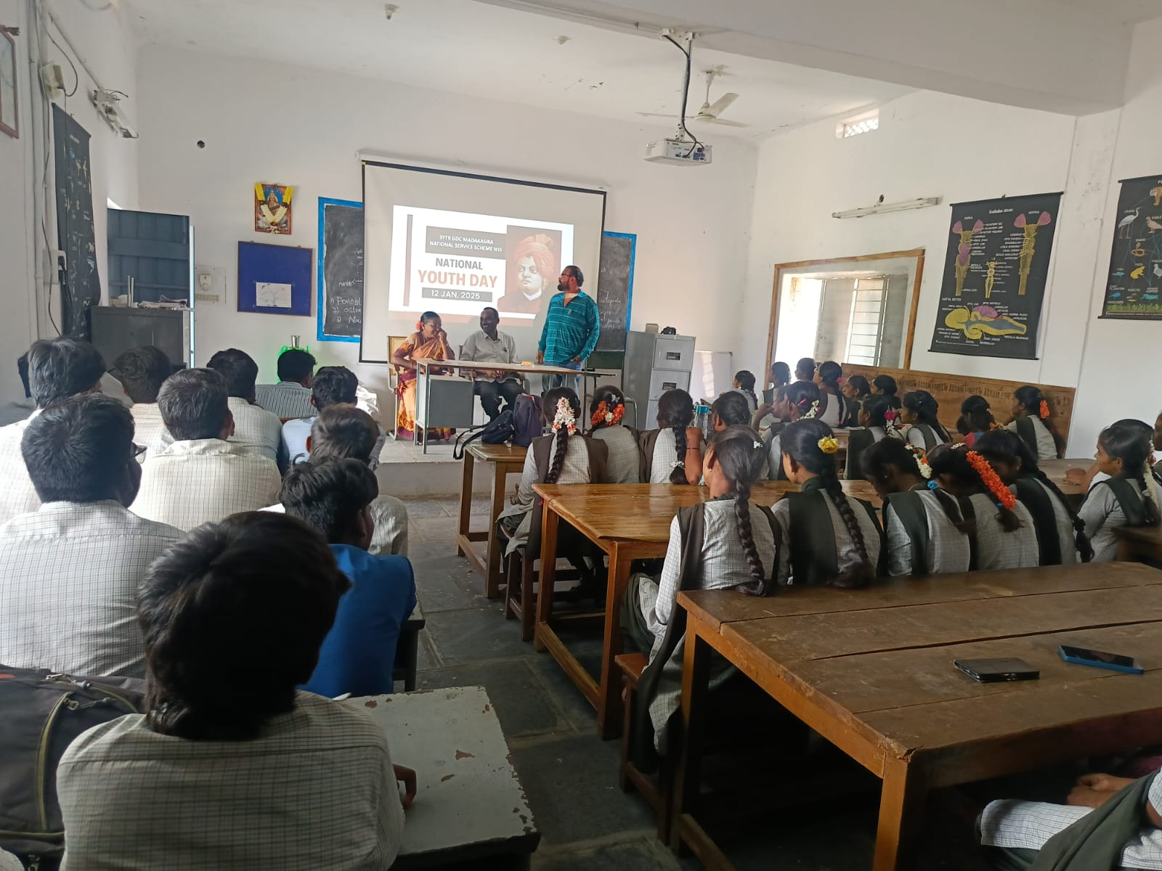
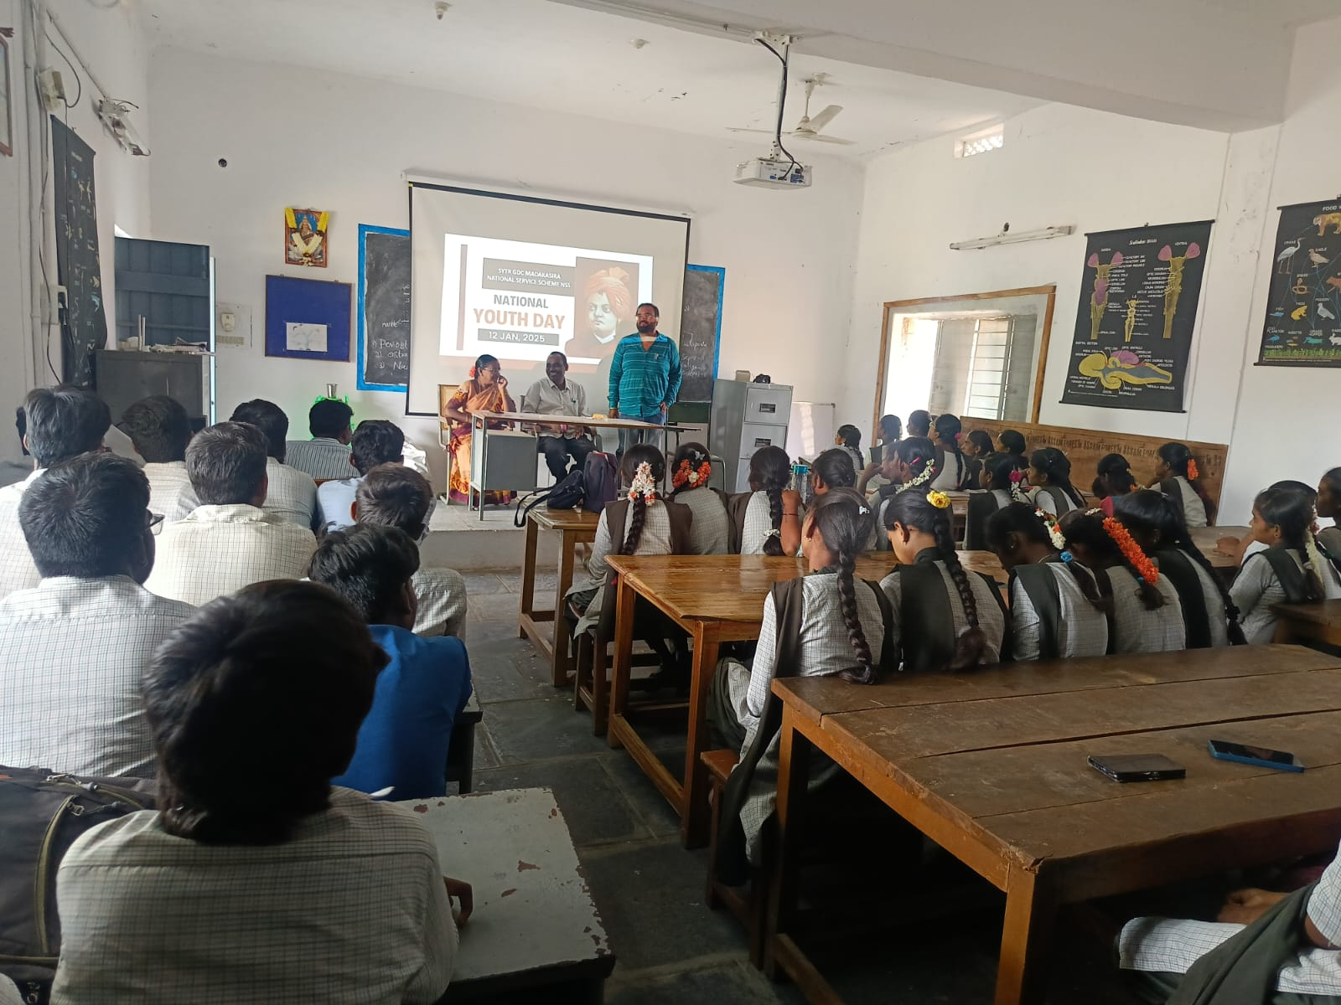

EVENT; Helping to accident victim by Staff ON16.01.2025

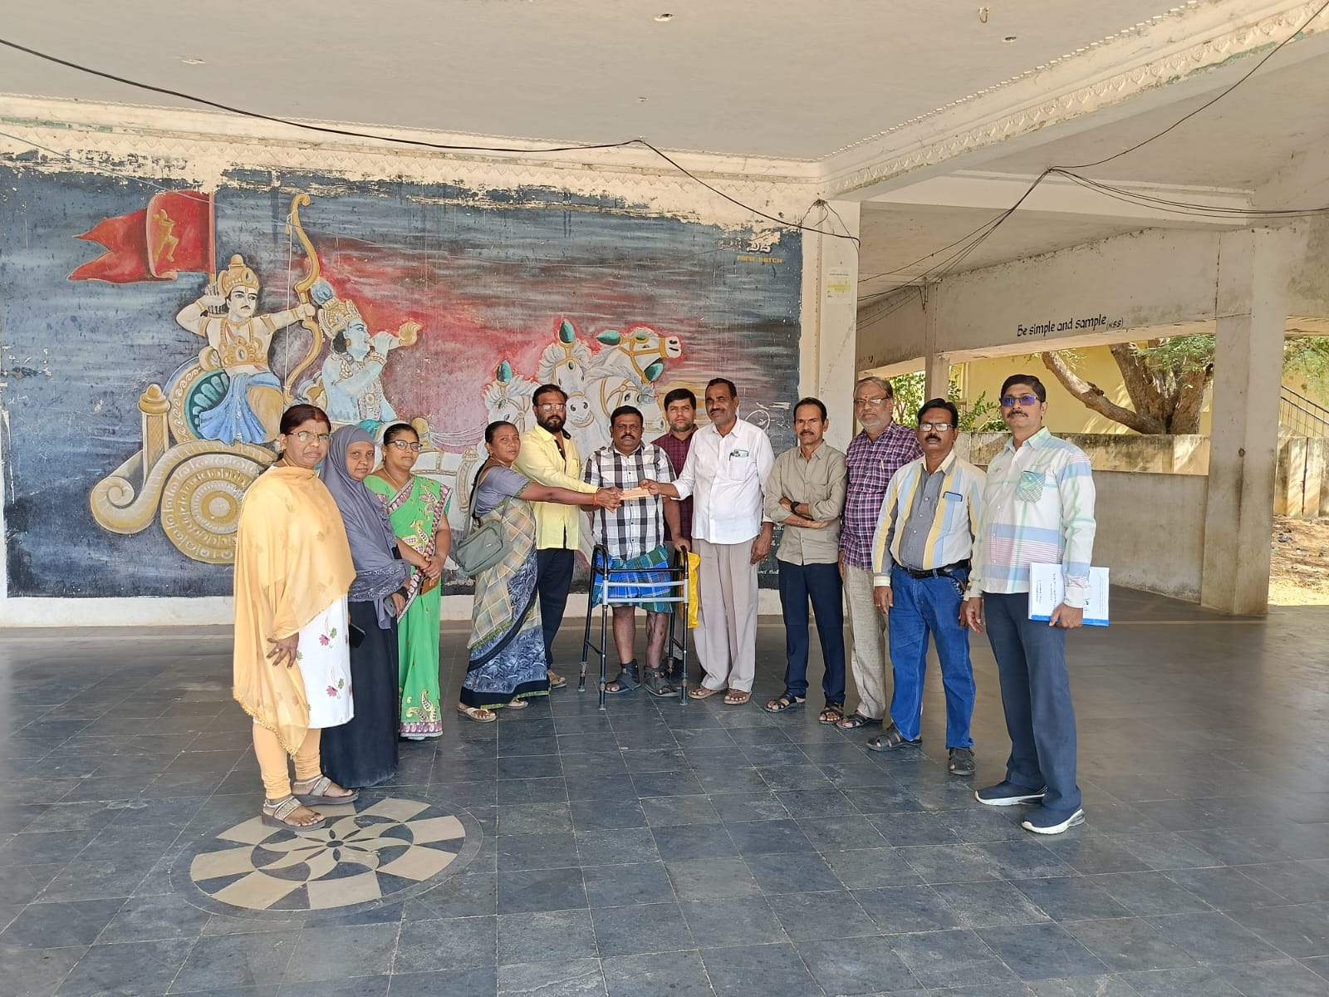
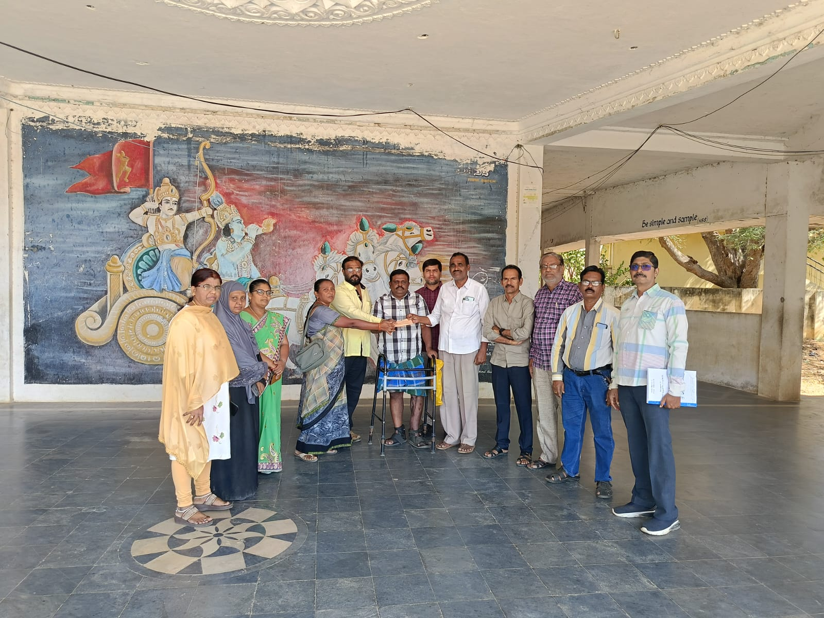

EVENT: Institutional Best Practice- Blood Donation Camp by College NSS Units.
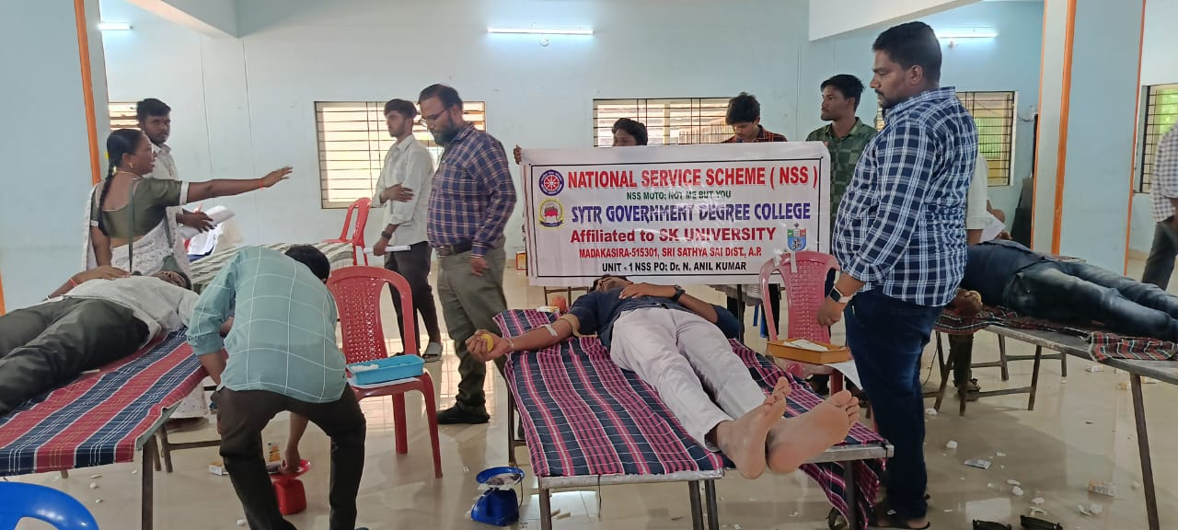
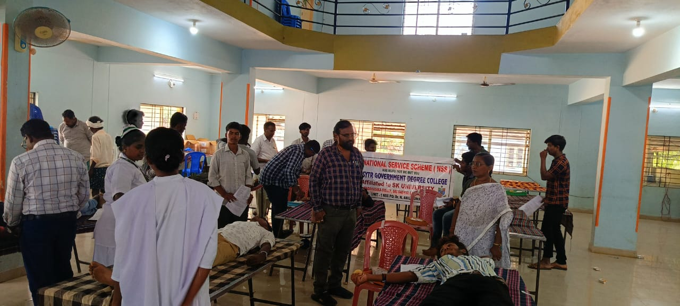
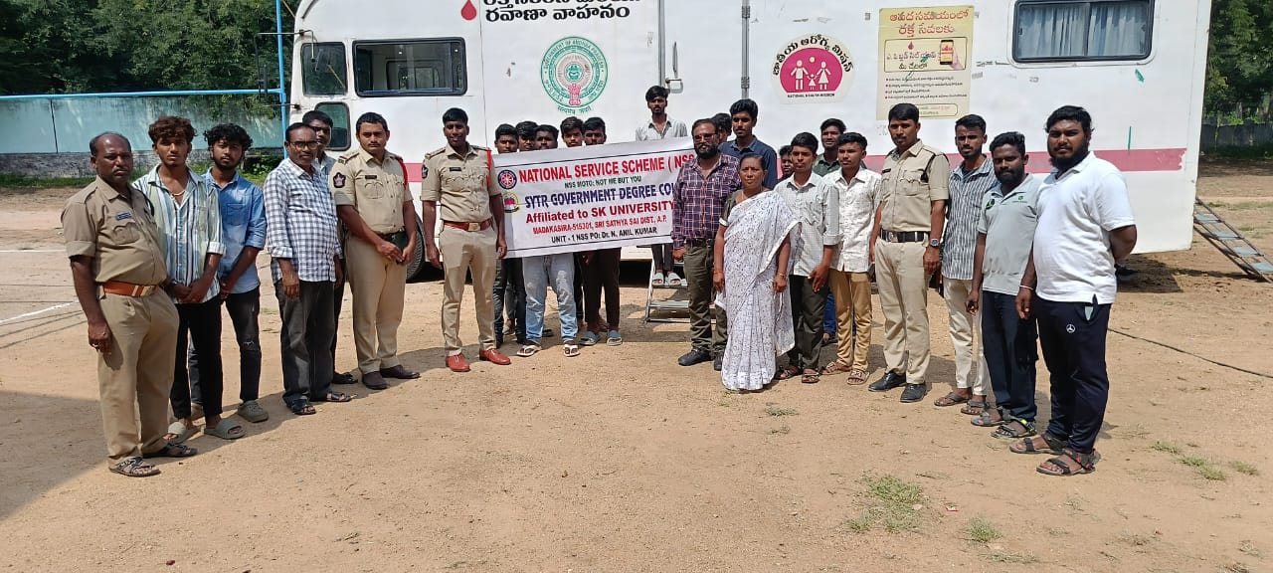

EVENT: Dr. Chandrasekhar Naik, HOD of Department of English conducted an Orientation program on CUET-PG Entrance Examination for various PG courses in Central Universities across the country and encouraged the students to register for the exam and try to get admission in the National importance universities on 20.01.2025.
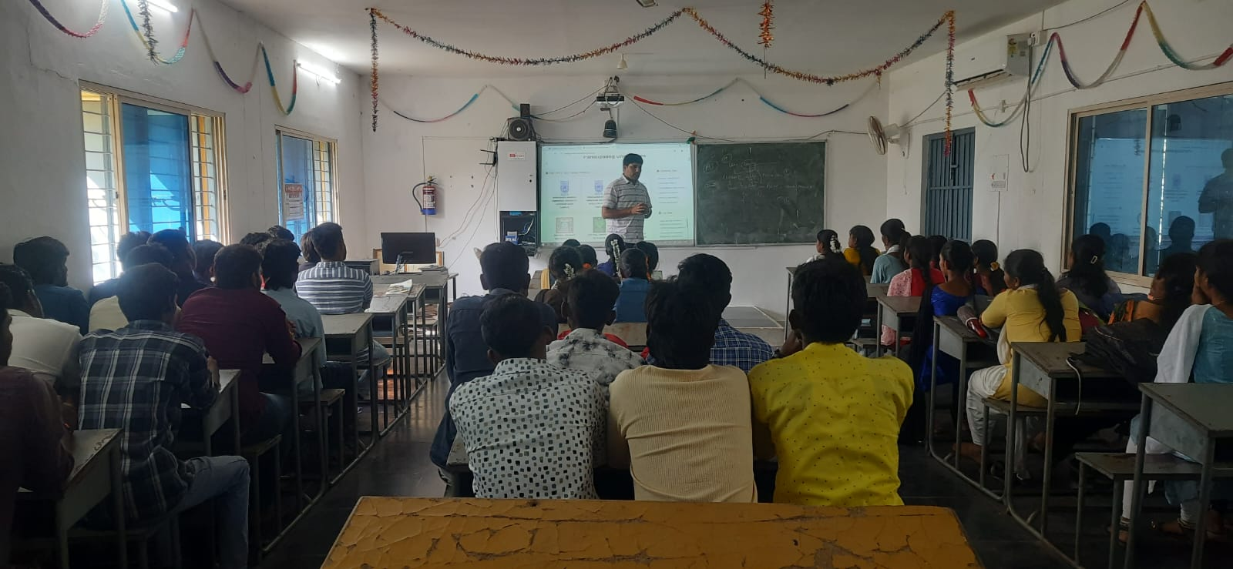
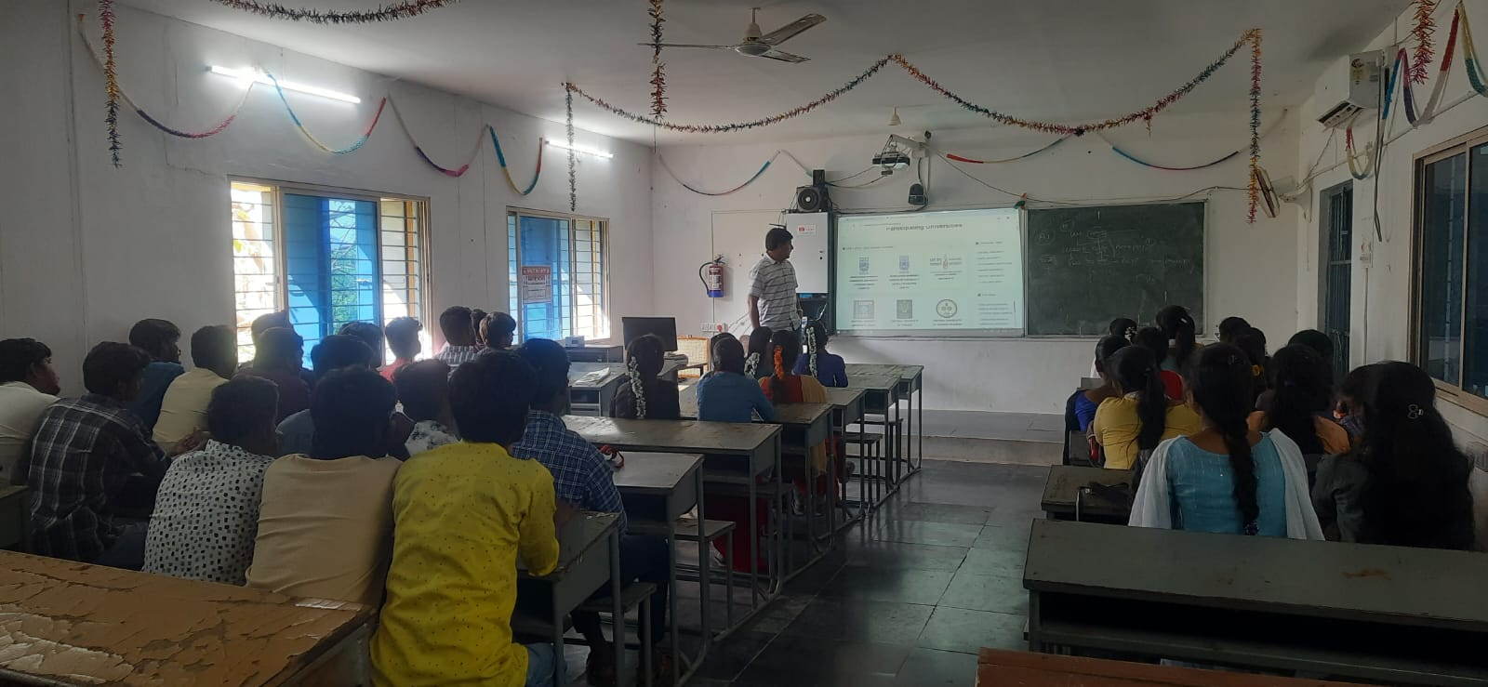

EVENT: Republic Day Celebrations on 26.01.2025.
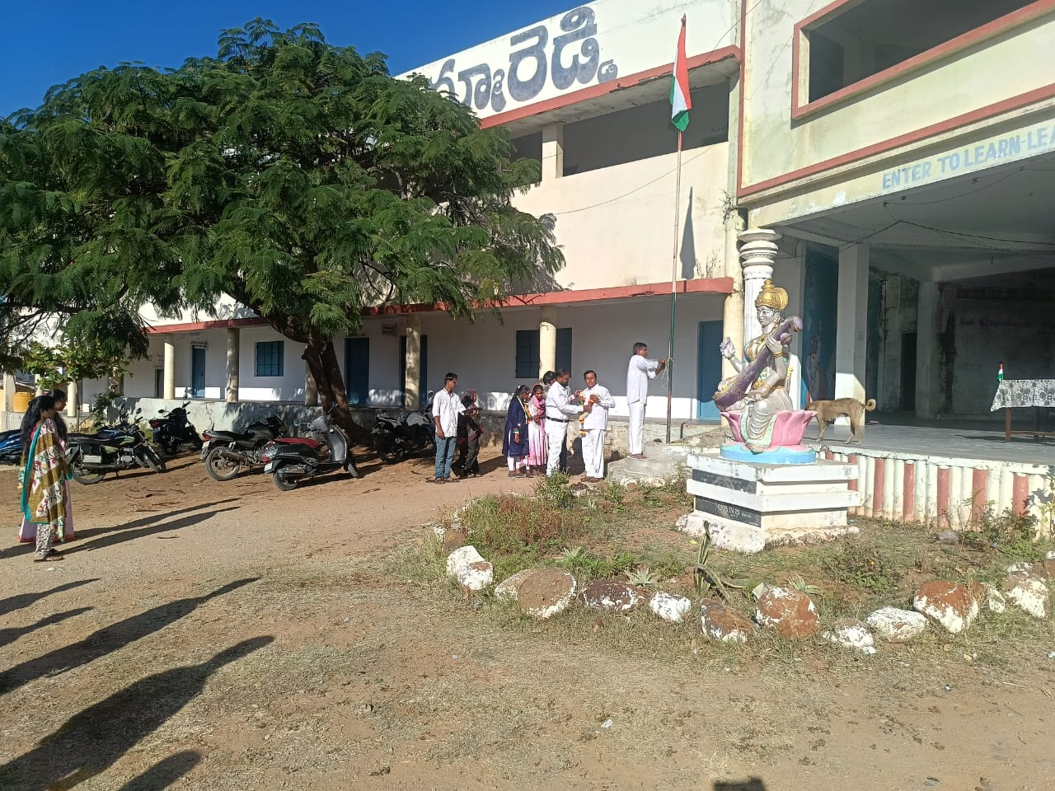
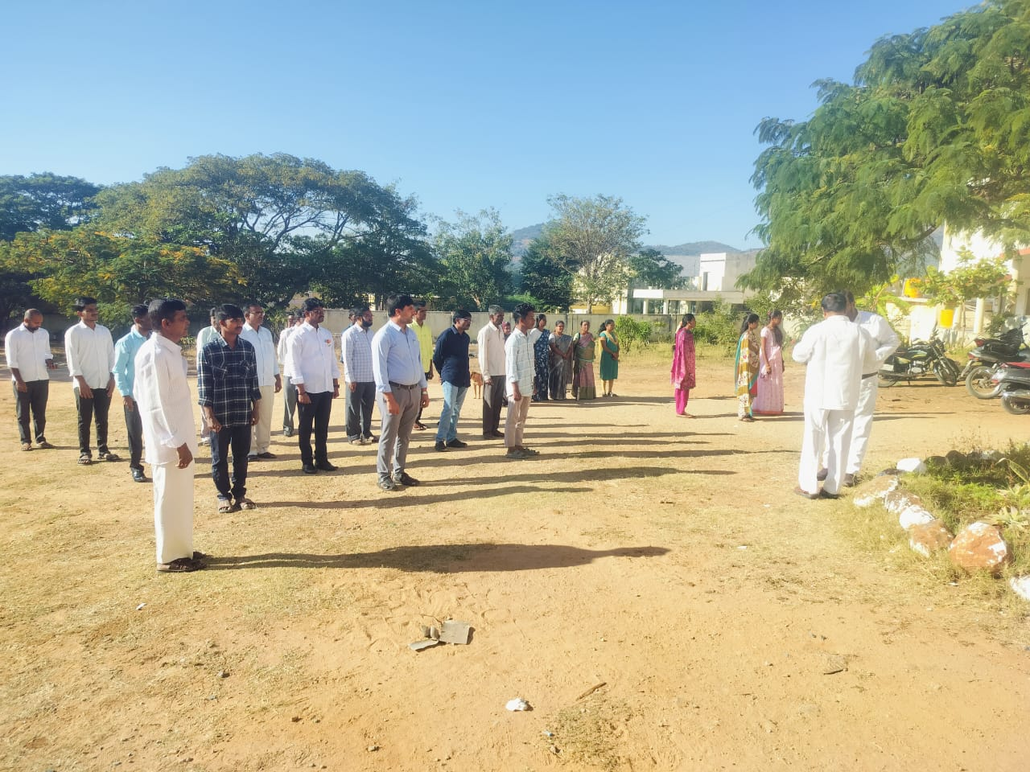

EVENT: Certificate Distribution to Trained Tailors and Beauticians under Skill Hub on 30.01.2025
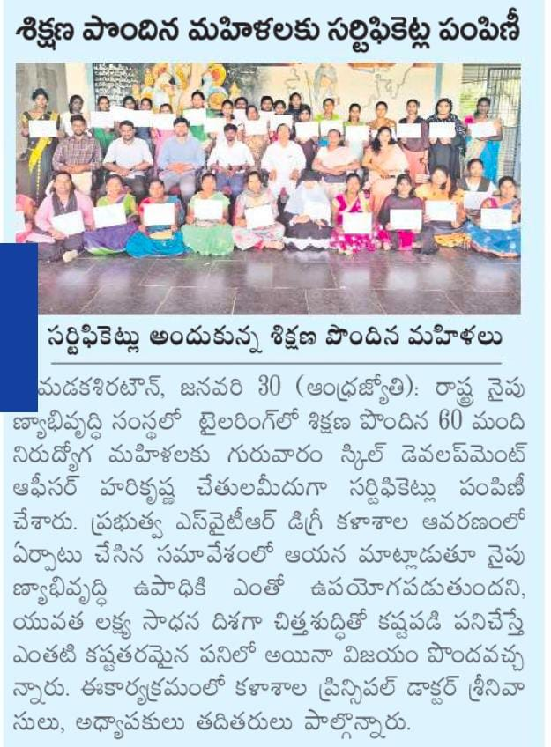
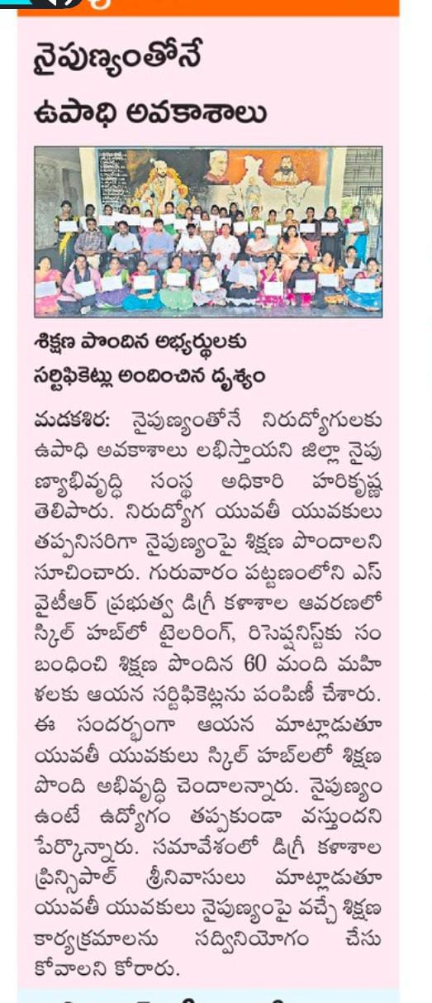
EVENT: Department of English Best Practice: Learning English through Videos 19.02.2025
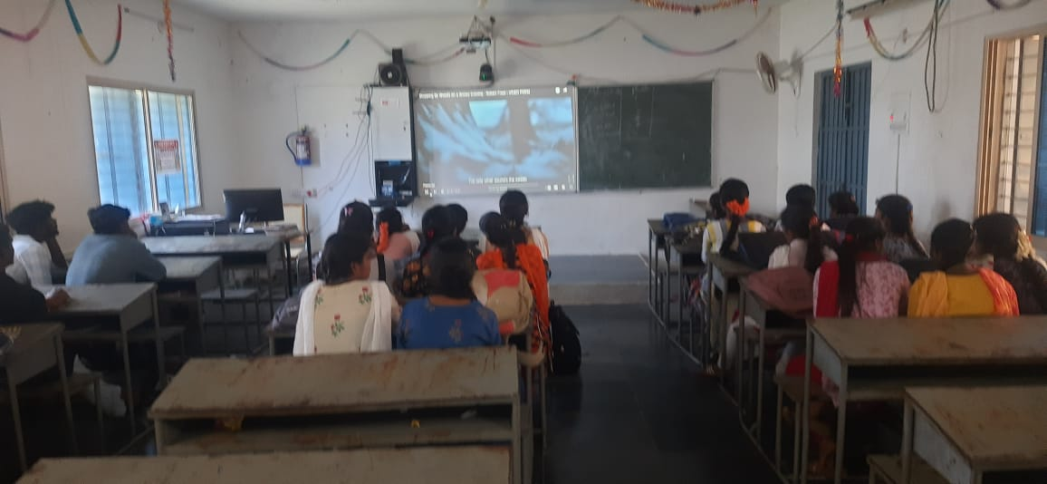
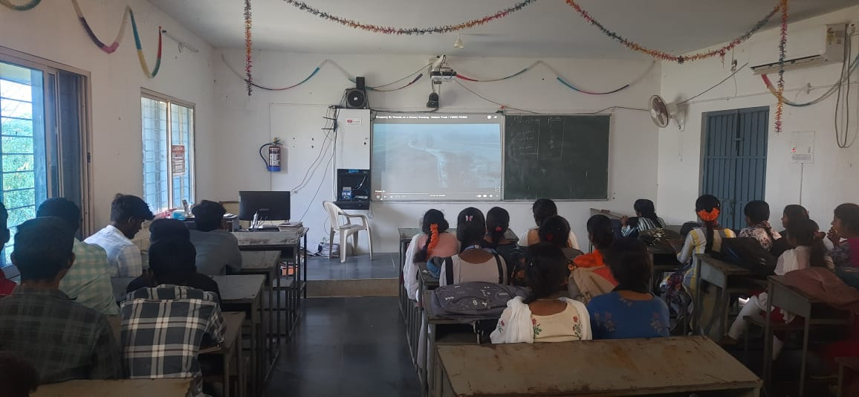

EVENT: Group Discussion on Business ideas on 04.02.25
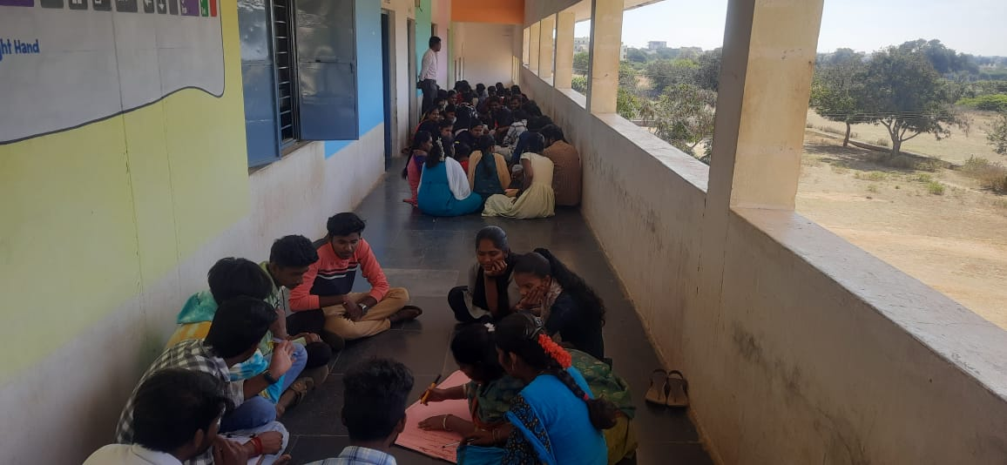
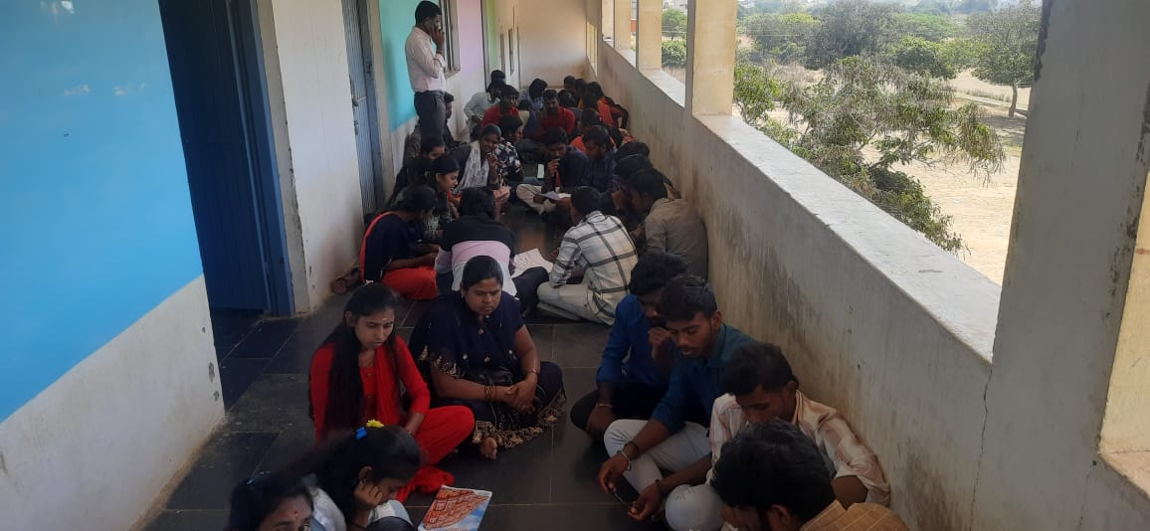

EVENT: World cancer Day ON FEB 4TH 2025 BY NSS UNITS
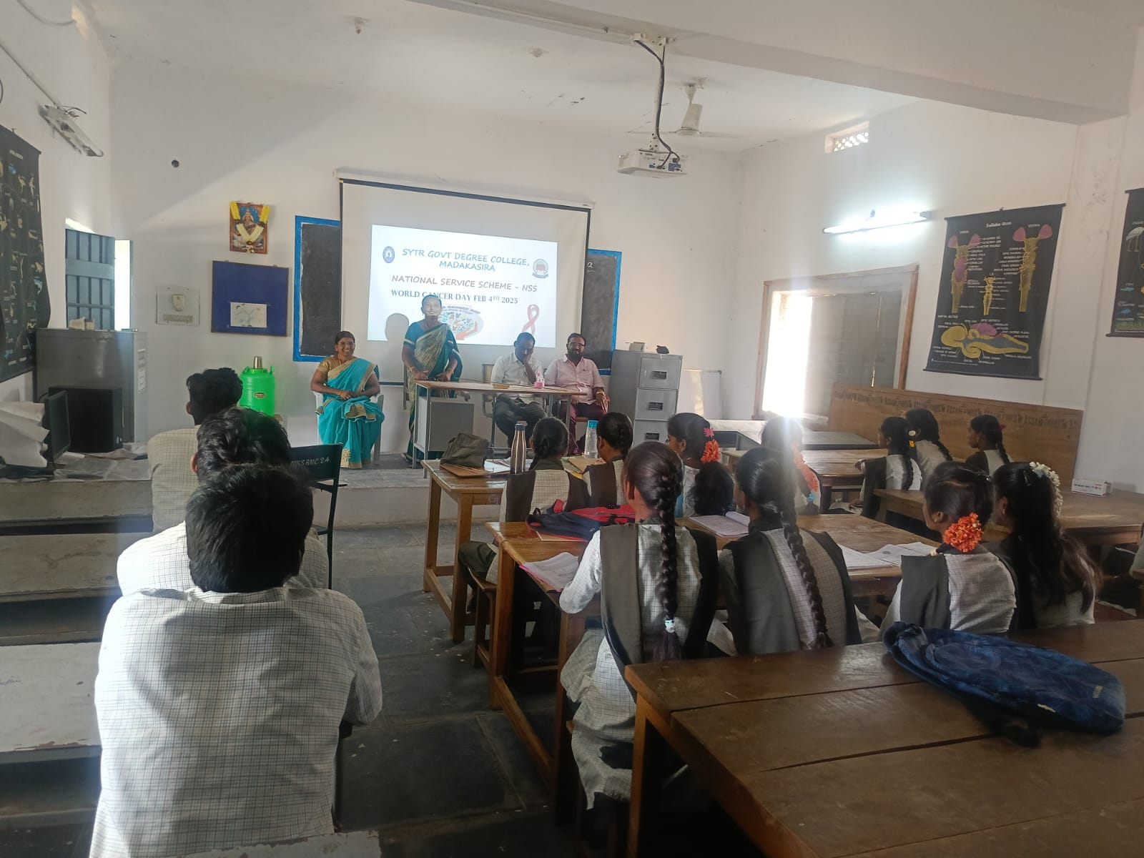

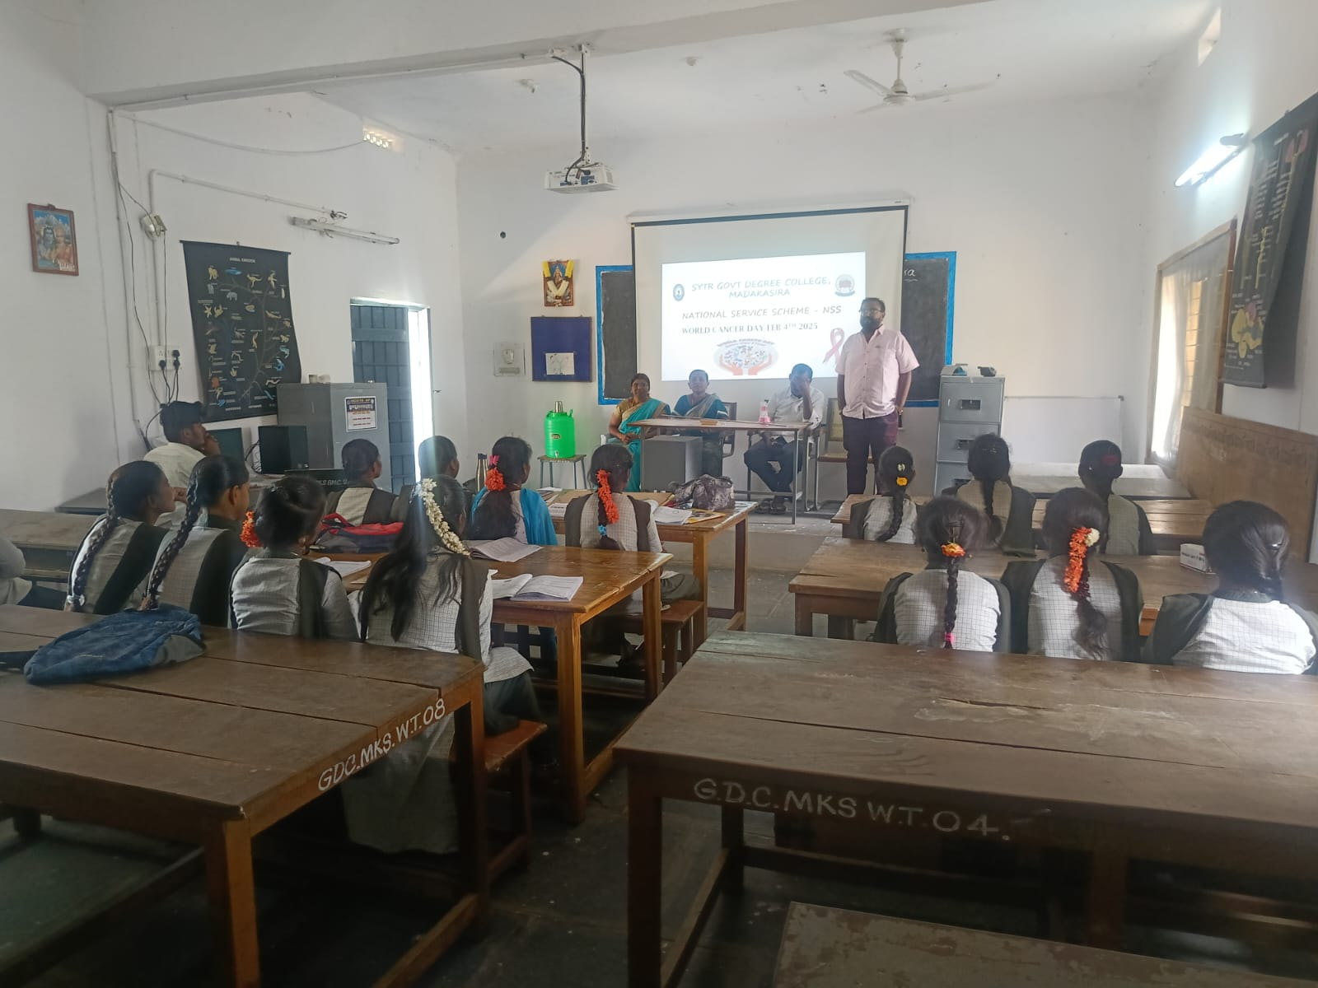

ALUMNI MEETING REPORT
SYTR GOVERNMENT DEGREE COLLEGE , MADAKASIRA
DEPARTMENT OF COMMERCE
ALUMNI MEETING REPORT

The Alumni Association of SYTR GOVT DEGREE COLLEGE MADAKASIRA "ALUMNI MEET 2025"- a programme facilitates, consolidate and coordinate Alumni Activities at SYTR GOVT DEGREE COLLEGE MADAKSIRA on 25/05/2025
The alumni meet is to reconnect with the Alumni and celebrate their success and various achievements. The Alumni started arriving in college by 10.00 a.m. and they were received by the registration team and they have been asked to fill the registration form. The Alumni Meet started with a welcome address by the alumni association president LOKESH . The meeting was graced by the Principal Dr. G.SREENIVASULU, S.SIVANNA HOD of Commerce, all the Commerce Deportment teaching faculty and non-teaching members also participated in that programme .
• They planned to add different passed out batches.
• About updating database of the alumni association.
• To take employer survey.

